Ejercicio 2

a)

|  |  |  |  |  |
| --- | --- | --- | --- | --- |
| **Orden que toma el Vértice** | **Vértices** | **Distancia (A,v)** | **Vértice Previo** | **Visitado** |
| 1 | A | - | - | 1 |
| 4 | B | ~~∞~~ 7 | A | ~~0~~ 1 |
| 6 | C | ~~∞~~ 10 | D | ~~0~~ 1 |
| 3 | D | ~~∞~~ ~~8~~ 6 | ~~A~~ E | ~~0~~ 1 |
| 2 | E | ~~∞~~ 5 | A | ~~0~~ 1 |
| 5 | F | ~~∞~~ ~~17~~ 9 | ~~E~~ D | ~~0~~ 1 |
| 7 | G | ~~∞~~ 13 | F | ~~0~~ 1 |

b)

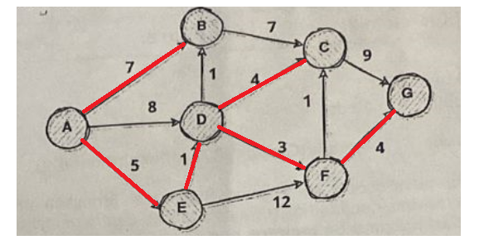

Ejercicio 3

Se asume que la arista (7, 2) no existe, porque formaría un ciclo.

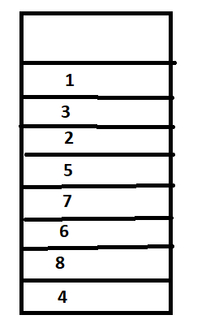

El orden topológico, desapilando los elementos de la pila sería: 1 3 2 5 7 6 8 4.